ZoE V2

Reboot: 17-8-25 Start: Aug 2020

Goal:
- Recycle HDPE milk bottles
- Recycle 3d Printer rubbish
- 1st HDPE into moulds
- 2nd Make 3d filament PLA, then HDPE

Source:
- Schools
- Cafes
- Retirement villages

Products:
- Shredded plastic
- Dish - Mould
- Hooks – Mould
- Sling Shot – Mould
- Fork – Mould
- Beams/ 50x50 angle etc
- HDPE Filament
- Building site parts (CCTV Mount, Extrusion End)
- Useful replacement parts (handels etc)
- Mobile large-scale printing (Hanging printer)

Research:
- Watch vids again
- Making Filament (FilaWinder)

Links:
- HDPE Filament Basics
- https://all3dp.com/2/hdpe-3d-printing-material-all-you-need-to-know/?fbclid=IwAR25rspnOXucKhxLk1w2fZhLK41qtvgAp3u2MedQMlsKQ1rS-n46iMI5DQI

- Filament Winder
- https://www.filastruder.com/collections/filastruders-accessories/products/filawinder

- Filament Extruder and Winder
- https://artme-3d.shop/

- How to make filament
https://www.youtube.com/watch?v=8beebuf3txc&t=313s
https://www.youtube.com/watch?v=RF05JBnNazA

- Filiment Palatizer
https://www.printables.com/model/680727-self-feeding-open-source-filament-pelletizer-remix/files Use these files
https://www.printables.com/model/672486-self-feeding-open-source-filament-pelletizer Documentation
Assembly vid https://www.youtube.com/watch?v=ythBhR1sLiQ&t=10s

- Microwave
https://www.thewarehouse.co.nz/p/living-co-microwave-20l-700w-white/R2987191.html

- Press
https://www.trademe.co.nz/a/marketplace/business-farming-industry/industrial/manufacturing-metalwork/presses/listing/5610297584

- Hanging Printer
https://hangprinter.org/about/

- Pet Prosthetics
https://www.3dpetsprosthetics.com/?fbclid=IwY2xjawNQRfNleHRuA2FlbQIxMABicmlkETF4NW9FSXV6MDZNRGtVbGRhAR7VP1yo-hyVu9RzvxWEw5xZARuPtVZjhJrN2S5GIlJ_iD-8pJ2bLskbshg1MQ_aem_a7VmxZcID44oElvleO7klg

Playing with Plastic:
- HDPE can be printed at 230-260 deg, shrinkage & warping is an issue

- HDPE: De-label bottles using heat gun
- HDPE: Clean and dry if required. Must be dry

- Store Plastic in covered container, to keep dust & contaminants out

- Must use clean gloves, with hot plastic
- Filament: 2 stage granulation, for consistent extrusion consistency is prefered
- 4.5mm sieve (Have 5mm, its fine)
- NEED: Cooling heat sink or fan
- NEED: Sieve vibrator
- NEED: Sharpen Blades. Grind the inner S shapes with a dremmel to create sharp edges

- Limit Handling shredded material – goes everywhere
- Small Shredding batches in case of contamination
- NEED: A Funnel & holding system, to transfer and regrind from Toot box to storage container
- NEED: Containment. (Spray booth, easy to clean)
- **Wash regrind in bucket, NEED: Sieve.
(Preferably not, store clean and covered b4 shredding)
- Use microwave to dry regrind at 40-60 deg, 30 sec on 5 min off, 5 cycles
- If its on the floor its rubbish

- Put magnet in Extrusion hopper, to remove metal
- For Filliment, Extrude at 3mm then palatize
- Use filament palatizer to cut up 3d filiment left overs, not shredder
- 0.8mm nozzle is norm but, 0.4mm does work

Fyi, what is often done in professional filament recycling is to first extrude at 3mm diameter, pelletize it, and re-extrude at 1.75mm Reason being is that a lot of your diameter variation is due to inconsistent feedrate of your extruder because of the inconsistent grind size, which is basically inevitable when working with regrind. Larger diameter filament is less sensitive to diameter inconsistencies, and if you then pelletize it, you end up with pellets that are roughly the same dimensions as virgin pellets. Then you will have a more consistent feedrate when extruding at 1.75 mm, which is far more sensitive to that. edit; by extruding the plastic twice, you're pushing it through extra 2 melt cycles, and thus degrade the polymers. Typically you'll only see massive performance degradation at like +5-10 melt cycles, but that's why they mix in virgin material to offset that effect. edit2; diameter swings are proportionally smaller with larger extrusion diameters. A 0.1 mm delta on 3mm isn't really noticeable. on 1.75 mm filament, it makes it unprintable.

In industrial plastic recycling, our industrial shredders and granulators often have water-cooled shredder compartments to combat this issue. Also, We use a two-step process with two very different machines; a primary finger or claw shredder turns the plastic into chips, then a separate granulator uses rotating knives with the proper screen to make consistent regrind.

I actually build and sell shredders like of similar size. Most of the problems you are having are related to thickness tolerances of the blades and fit to the axle aswell as spacing from the box. Another is the sharpness of the blades, they are probably very dull. Also having a smaller sieve than blade thickness is causing the shreds to be re-shred many times. This together with the dullness of the blades is also a cause for the jams and the heating up of the shredder and the plstic. If you disassemble the blades, you can grind the inner S shapes with a dremmel to create scharp edges. And the same for the curves of the fixed blades. Also my preferred blde configuration is a V shaped double spiral so that the blades on the side are the front runners and the middel blades are last to complete the cutting cycle. This way all material is pulled to the middle.

- Pie Mould
  - 90g plastic
  - Use paper template to lay out on toaster
  - Pre heat moulds
  - Remove inside paper and place on mould
  - Remove outside paper and clamp down mould

- Angel Mould 70g plastic
- Long Block 50g plastic

- Extruder flow rates??

Farmers Market:
- Goal: Get info out / feedback
- Powered Site
- 2 x 3d printers
- Screen playing vids
- Ask for plastic lid collection points, have hand outs FB page? Or to much
- Logans 3d tooth paste tube thingy - Free
- HDPE Boat Benchy – Free (Blue HDPE bot caps)
- Pie Dishes – Gold coin/Free
- Hooks – Gold coin/Free
- Sling Shot

Machines:
- ZoE – Zhredder of Extruder
- Microwave – dry plastic/filament
- Press, for moulds (Trademe 6 Ton $160)
- Filament Winder
- Filament Pelletizer
- CNC for moulds
- Hanging Printer

Machine Improvements:
- Shredder – Skert to seal around it to stop plastic escape and spread
- Shredder – Chain Tension
- Shredder - Chk spacer on shaft is in correct position
- Shredder - Vibrator on sieve to help stop build up
- Shredder - Heat sink on outside of box
- Shredder => storage container funnel

- Extruder - Use PLA Pro for hopper manifold
- Extruder - Print funnel adapter to suit 160mm pipe
- Extruder – Nozzel size options
- Extruder – Barrel to mould addaptor

Press:
- Wooden Fram
- Scissor Jack
- Electric moto (fan from B’s)
- Trampoline springs

Hanging Printer:
https://hangprinter.org/about/
Extruder mounted vertical on DM20 ropes
Mount from shed apex
Fix 2 x mounts to floor, third mount on vehicle
Dynamica DM20 rope https://dynamica-ropes.com/products/dm20/

ATX PSU Plug
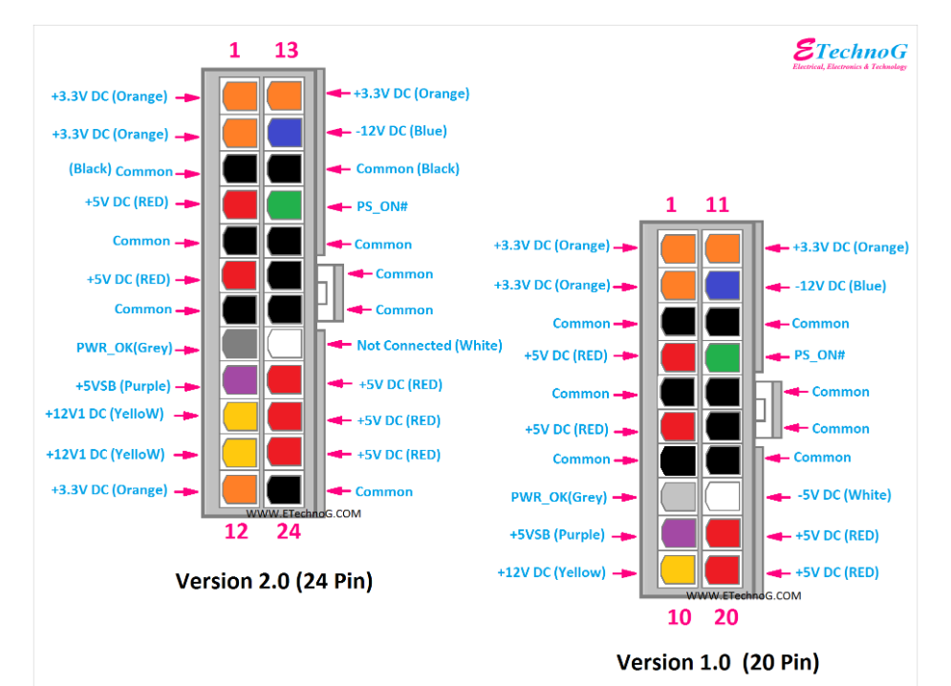

Grn PS_ON# to Gnd, to turn on

